Your name:

Class:

More work is needed Average
Good Excellent

Your Score:
Time: 40 min.

1- Sara is in grade two. She has written few sentences. But they have some errors. She has written some words with capital letters. The words are not proper nouns. Write these words with lower case letters to do the correction. (1/5)
I have a beautiful KITE, it is orange. It has pictures of NINE small BEEs. It can go high in the sky.
BEE KITE NINE
…………………………………………………………………………………………………………………………………………………
2-This will be your ID card. Complete it. (3)
Iranian Pool Membership Card
First name:……………………………………………….
Last name:…………………………………….…….……
Age:………………………………………………………….
Phone number:…………………………………………

Your
picture
here

3- Mr. Alavi has a store. His 7 years old son, Mehrdad, wants to help his father. He should count the cookies, chocolate boxes, …
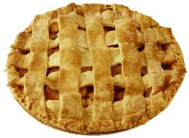
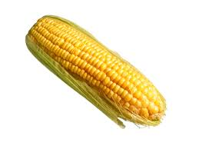
a) Let's see if he counted them correctly!!! ….hmmm…No!...all of them are wrong. Look at the pictures, count them and write the correct numbers. (1/5)
7 8 5
Mehrdad's numbers:
correct numbers: ………….. ………………… …………..…

b) Mehrdad is not good at mathematic. Do the calculations and write the answers to help Mr. Alavi. (1/5)
4+5= 8-6=
6+8= 79-49=
5- Few students have registered in ping- pong classes. Write their names with correct alphabetical order, in the table given below.(2)
Ahmad - Kimia - Ehsan -Bahman- Pari - Nima -Tina -Iman
Names
Gender(b,g)
Proficiency level(w,g,e)

6- Leila wants to send invitation cards for some parents. She wants to write their last names on the back of the card. Help her to circle the last names given below.

Mr. Ebadi , Nima , Anita , Miss Moniri , Mrs. Behnam , Samira

7- You and Sara are playing a game. Who can make more meaningful words with the given letters will be the winner. Try your best to win the game. (2)
b - n - e - s - g - a - m - k - i - p - t - u
Your words:
………………………………………………………………………………………………………………………………………….
…………………………………………………………………………………………………………………………………………

